This Paper contains the three questions used in the EEE4007 examination plus one others used as an example. In the examination the paper will consist of two sections of three questions each as per last year`. Three will be from my part and three from Prof. Riza. Students mus answer two out of three questions in each section.

You may require the following:
Charge on electron, q = 1.60x10⁻¹⁹C | Permittivity of free space, ε₀ = 8.85x10⁻¹² Fm⁻¹
Boltzmann constant, k = 1.38x10⁻²³ JK⁻¹ | Planck’s constant, h = 6.63x10⁻³⁴ Js
Speed of light in vacuum, c = 3.00x10⁸ ms⁻¹ | Mass of electron, m_{e} = 9.11x10⁻³¹ kg

1. | a. | Using diagrams where appropriate, explain how a light emitting diode (LED) operates. Your answer should include a discussion the principles of operation a diode, and for the LED the relationship between light output power and voltage and current. It should also explain where the energy being carried away in the form of emitted light came from, with reference to the band structure of the material in the junction. | (8)
 | b. | A high brightness green LED using an InGaN active region is forward biased to give a current of 350 mA with a drive voltage of 3.4V. Using a so-called integrating sphere all the light emitted can be detected and in this case a power of 40 mW at a wavelength of 530 nm was measured.  - What is the external efficiency of this device  - What is the wall plug efficiency  - Explain the difference between the two values calculated above. | (4)  (2)  (2)
 | c. | The InGaN active region normally is a quantum well sandwiched between layers of GaN. Due to the piezoelectric nature of the material and the strain in the well the conduction and valance band profile looks as shown in the figure below, ignoring the effects of band bending due to any applied bias. For this figure sketch the form of the ground (lowest energy) state electron and hole wavefunctions and suggest what will happen to the wavelength of emission and the quantum efficiency of an LED as the well width is varied. Explain clearly your reasoning in all parts you your answer.  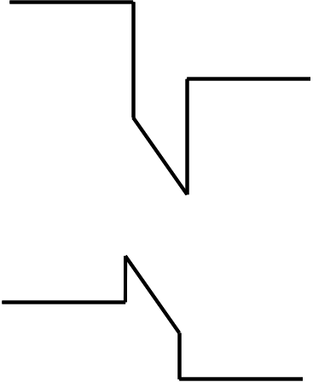  Figure 1 | (4)

2. | a. | Schrödinger’s Equation is given by:  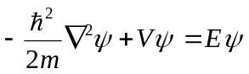  For this equation describe what is meant by  and give an equation in classical physics that it is equivalent to. | (3)
 | b. | Use Schrödinger’s Equation to obtain an equation for the electron energy levels in a quantum well (QW) with infinite barriers. | (6)
 | c. | Assuming that the potential barriers for both electron and hole energy levels in a GaAs QW are infinite, estimate the wavelength of emission of a QW LED if the width of the well is 6 nm.  GaAs Electron Effective mass: 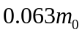  GaAs Hole Effective mass: 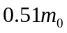  GaAs Bandgap: 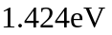 | (4)
 | d. | In reality the GaAs quantum well is surrounded by AlGaAs barriers which will have finite barrier heights. Describe the boundary conditions required to obtain a solution and suggest how the actual wavelength of emission might compare to that estimated in part (c). | (3)
 | e. | A “superlattice” is a structure where a large number of quantum wells are grown, separated by thin layers of the barrier material. A series of 100 GaAs quantum wells, with a thickness of 5 nm, are separated by thin AlGaAs barriers, also with a thickness of 5 nm. For this structure explain what you would expect to happen as a result of the very thin barriers between the quantum wells and suggest a method for solving this using Schrödinger’s Equation | (4)

3. | a. | i) For a homojunction semiconductor laser, derive an expression for the minimum possible operating voltage as a function of the laser wavelength  ii) Use this expression to estimate that minimum voltage for a GaN laser operating at 420 nm. | (8)
 | b. | Semiconductor lasers are used in optical data storage systems.  i) Briefly describe how a laser can read information stored on a DVD-ROM.  ii) State two key advantages of a semiconductor laser over other laser types for this application.  iii) Why can Blu-ray discs can hold substantially more information than a DVD | (8)
 | c. | A 300 μm x 300 μm chip of an InP – InGaAsP (E_{g(InP)}=1.34 eV; E_{g(InGaAsP)}=0.9 eV) double heterostructure with cleaved edges is irradiated continuously with intense light from  i) A CO₂ laser with an operating wavelength of 10.6 μm  ii) A Nd-YAG laser with an operating wavelength of 1.06 μm  Explain what you would expect to observe from the surfaces and edges of the semiconductor chip in each case. | (4)

4. | a. | i) Explain briefly why a cavity is required in order to achieve laser action  ii) Show that the optical gain per unit length at laser threshold, g_{th}, is equal to.  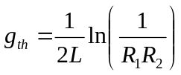  Where R and L are the mirror reflectivities and cavity length respectively. | (6)
 | b. | A graded index separate confinement heterostructure (GRINSCH) semiconductor laser structure operates at a glass fibre optics communications wavelength.  i) Calculate the mirror reflectivity, assuming it is simple given by Fresnel reflection,  ii) Hence using your own assumption for the cavity length estimate the threshold gain for the device. | (5)
 | c. | For your laser in part (b) calculate the wavelength spacing between the allowed laser modes. | (4)
 | d. | Briefly describe why multimode behaviour can occur in a semiconductor laser and suggest one method to prevent it. | (5)

